# G A M M A S T I R L I N G E N G I N E - M A R C H 6 , 2 0 2 0

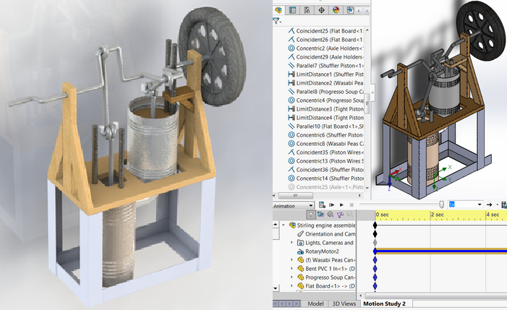This was a significant project for me, because I learned a lot. This was the assembly that I did with moving components. I learned to utilize the concentric mate to allow the pistons to move, and to use the limit distance mate to make sure that if I decided to change the length of the rods, that the pistons would stop at the bottoms of the cylinders, instead of moving through them. This was also the first assembly I learned to define sketches externally. I was able to define the wooden frame's sketches with objects in the assembled engine. I also learned to do basic animations, and make the engine continuously rotate.

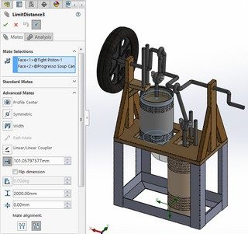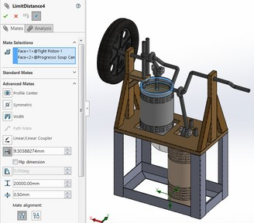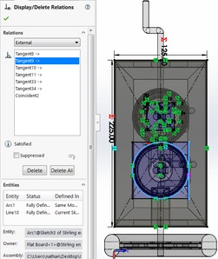

# V A R I A B L E P L A N E T A R Y G E A R B O X - A U G U S T & O C T O B E R 2 0 2 0

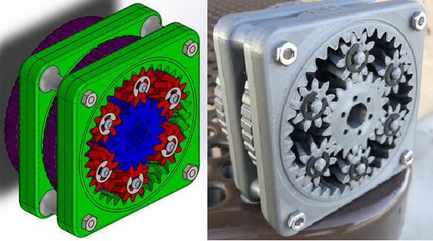This project was a significant learning experience, and an important step in allowing me to make my transmission later on. Interested in building a generator, I needed a gearbox. However, I couldn't find the exact size that I needed online, so I decided to make my own gears. In making my custom gears, I learned what an involute was, an equation driven curve to achieve the tooth profile. Using variables, I was able to control things like pitch diameter, pressure angle, and the teeth each gear had.

I then went a step up in October, and decided to make a planetary gearbox. The variables you could input were: The ring gear pitch diameter, the ring thickness, and the number of teeth of the sun and planet gears. Instead of customizing the sun's and planet's pitch diameter, they would be automatically calculated based on those four inputs. They would be made to automatically fit within the ring gear, and have the proper size ratio.

In the assembly, I learned how to control planetary gear ratios I learned that you needed two inputs. I typically held the ring gear (inputt #1), and spun the carrier (input #2), driving the sun gear, outputting higher speed. I learned How to get multiple ratios with one gearbox, including reverse (holding the carrier, and outputting either the sun or the carrier), or higher torque (holding the ring, and spinning the sun, outputting the carrier).

Learning that helical gears were quieter, and could take more abuse, turned my straight cut spur gears into helical ones with a sweep command. However, helical gears will push each other out due to their angled teeth producing axial force. Instead of using a thrust bearing, which is normally how this is solved, I instead put a helix counterclockwise, and turned my gears into herringbones. Herringbone gears have all the same advantages as helical gears, however, the axial forces they produce are cancelled out, because the helixes go in opposite directions. This double helix also allows the gears, if they are put on an axle, to be locked axially, since the angled teeth will prevent the gear from sliding in and out. This is why the E clips on the planetary gears are only used to lock in the carrier to the box, and is why the sun gear is held in place despite there not being set screws, clips, or any other locking hardware.

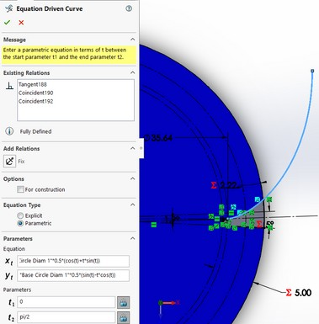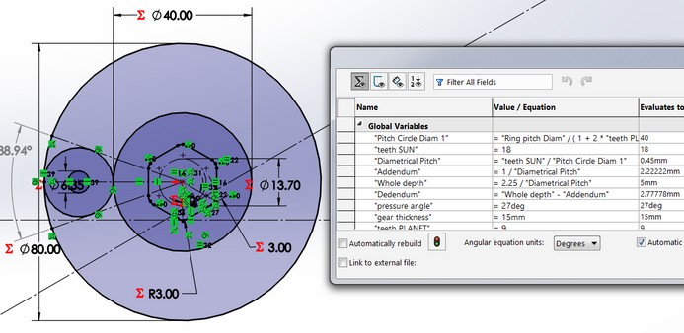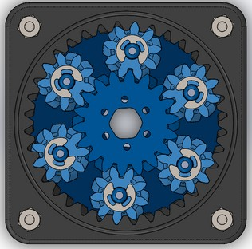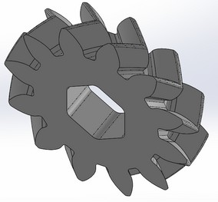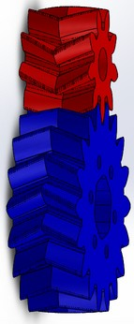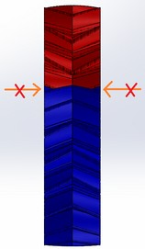

# V A R I A B L E C Y C L O I D G E A R B O X - D E C E M B E R 7 , 2 0 2 1

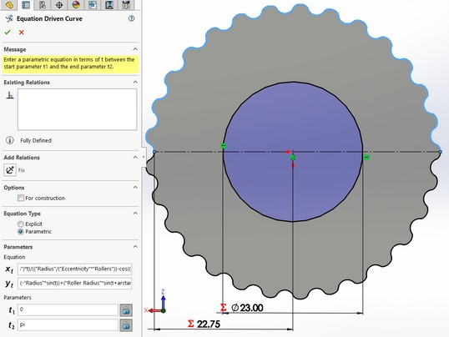Wanting to explore more gearing, I tried my hand at making a cycloid gearbox. Here, I again used an equation driven curve to generate the gear profile, and controlled it's parameters with global variables.

Like the planetary gearbox, the cycloid gearbox requires two inputs. Typically, the ring (whose teeth are called rollers) is held in place, and the eccentric shaft is spun. When the cycloid makes a full rotation around the ring, the output, a disk whose pins go through the cycloid, will rotate once. This offers a heavy reduction.

ANother way to drive it is to hold the disk with pins still, spin the eccentric shaft, and output the ring. This is what I have proposed for an arm.

One problem with the cycloid gear is that because it spins eccentrically, it wobbles. This is why I have ways of mitigating it. One way is to add a second disk on top, 180 degrees opposed to the first. However, this solution is not exact, as the mass isn't equally cut radially, as shown below. This is why my favored solution is to make an exact copy of the first cycloid, and place it 180 degrees, The cost of this is making the pins on the disk shorter.

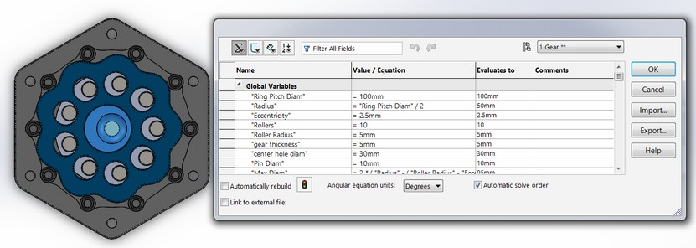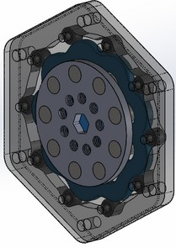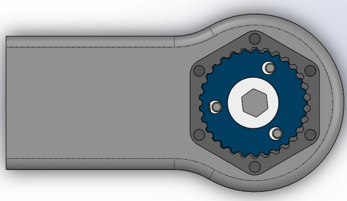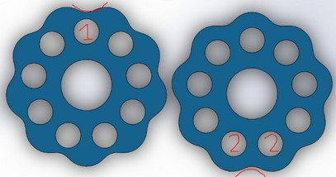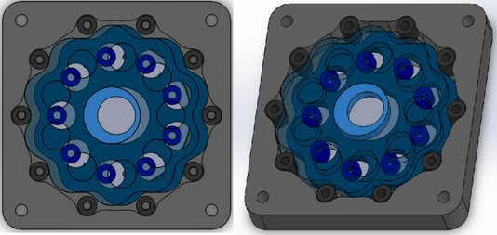

# T A R C R O C K E T - N O V E M B E R 1 0 , 2 0 1 9

This was the one of the first projects I did independently. My robotics team gave me SolidWorks in late June of 2019, and I had been making parts and assemblies for them. This was one of the first times I started using SolidWorks for myself, and I managed to design my own rocket for the TARC 2019-2020 season. Unfortunately, due to COVID, the rocket did not get to compete.

I designed all the components of the rocket myself; I decided to use a Haack nose cone, because I read that it minimized drag. To achieve that shape, I used an equation driven curve, with variables allowing me to change its length, base width, and other factors. Similarly, I also designed the fins. In previous competitions, including the 2018-2019 season in which we competed nationally, we had used tube fins. However, not wanting to rely on drag to control the height of the rocket (due to it being affected by wind and temperature, which are out of my control), I tied minimizing drag by making my fins an airfoil shape. I ended up with two fins: one asymmetrical airfoil to give the rocket spin, and one symmetrical airfoil, to make the rocket go straight. In the end, not wanting to risk anything, I used the symmetrical fins. I also completely redesigned the transition cone (the one in the middle that transitions the thinner top tube to the wider lower tube), and the tail cone. Previously, the team used sharp edges and cones with triangular cross sections for both. However, wanting to minimize drag as much as possible, I used style splines to accurately create a curvy shape for each.

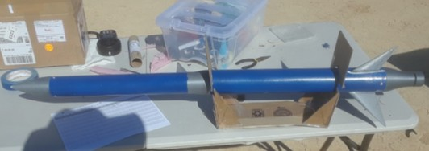When I finally launched, the highest my rocket went was 1209 feet. Although the target was 856 feet, the performance of my rocket suggested that a weaker, and thus cheaper motor could be used to launch the rocket to the desired height.

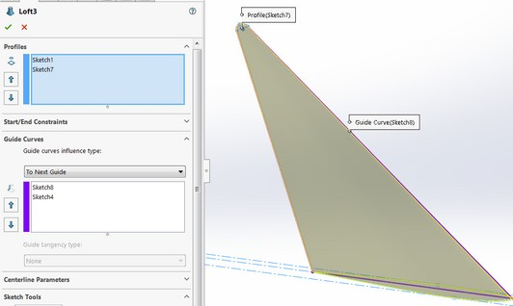I learned how to use the Loft command with this project. Here, I needed to transition the airfoil shape to a single point at the very tip. However, instead of having the contours from the edges of the airfoil to the tip be straight lines, I wanted it to conform to an angled wedge shape with a rounded tip.

This is when I learned to use guide curves properly.

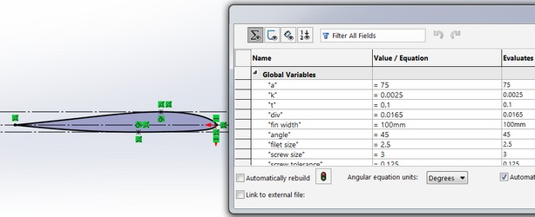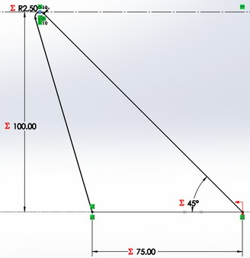

# T A R C R O C K E T - N O V E M B E R 1 0 , 2 0 1 9 - - - C O N T I N U E D

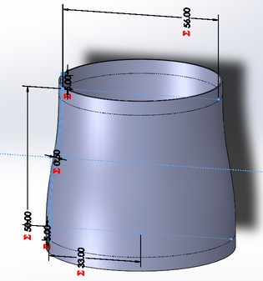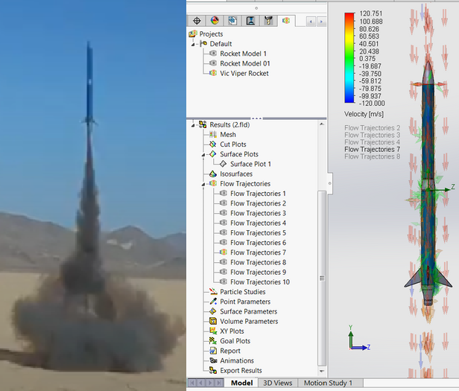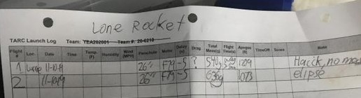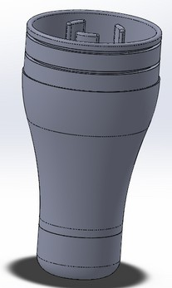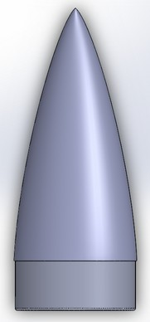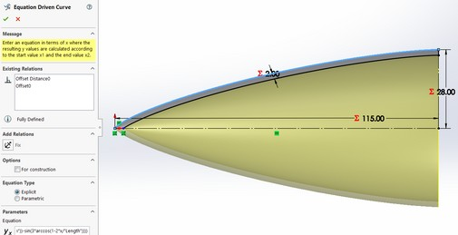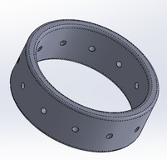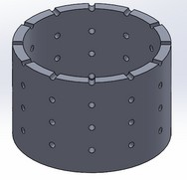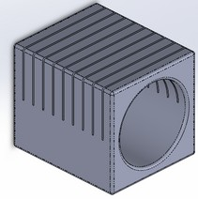

In this project, I also experimented with the flow simulation add in. Although CFD's may be inaccurate, I wanted to get an idea of the drag before actually launching to improve my parts. I set a high velocity downward flow against the nose of the rocket, and let the simulation run and generate graphics. I predicted that as long as the color gradient of the arrows doesn't change too much, then the drag will have been minimized. This is because the redder the arrows, the faster the velocity of the air. As long as the air didn't slow down too much after hitting the rocket, then it would have indicated that I had successfully minimized drag.

I had also designed tools to make the manufacturing process easier. Because I lack precision when drilling on the tubes, I created a ring with holes to guide the drill properly.

# P R E V I O U S R O C K E T V E R S I O N S A N D P A R T S - J U L Y - O C T O B E R 2 0 1 9

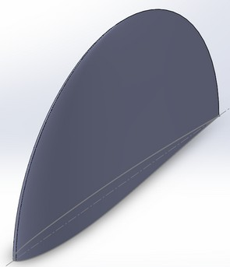Prior to settling on the final design of my rocket, I brainstormed many ideas for it, and used SolidWorks, which I had just recently acquired, to visualize and make them. In my view, we had barely made it to DC in the 2018-2019 season, so I came up with many proposals to make the rocket flight more predictable. I settled on reducing drag, since unlike our control over the mass of the rocket (we could add or remove weights to it), drag was dependent on the weather.

I created several nose cones: a conical nose cone, which could have its tip swapped out to be rounded, or pointed, an elliptical nose cone, and the Haack nose cone, which I finally settled on, since it reduced drag the most. As seen below, I used several variables for the conical design. This was the first project in which I extensively used variables to control the shape of my object, and where I learned to fully define everything without using the fix relation.

I also read that elliptical fins were suited for model rocketry, and wanting to avoid just extruding an ellipse, which would have created a flat face for the wind to drag against, I opted for having an elliptical and airfoil shaped base in the form of an elliptical fin. However, the boss and cut extrude operations that I normally went with did not give me the proper desired shape. This was when I first learned to use the loft command. This would make me dive deeper into SolidWorks, as after that, I was excited about all the curvy shapes I could make.

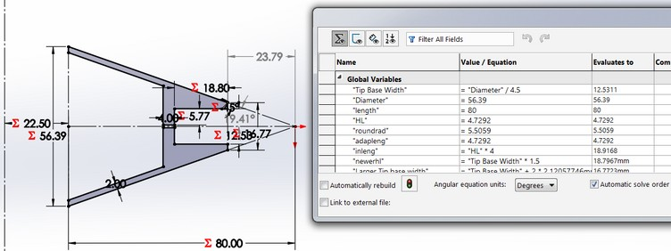

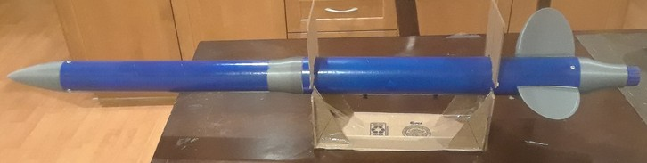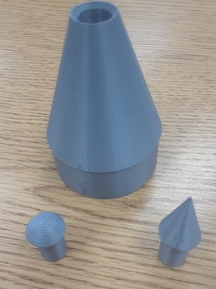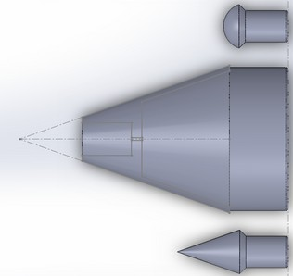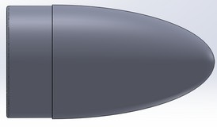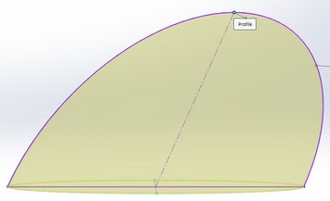

# M A G N E T D R U M - J U L Y 2 0 1 9

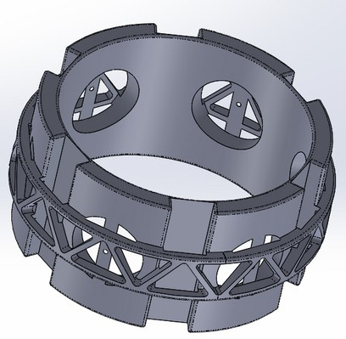At this time, I was given SolidWorks by my robotics team recently on June 29, 2019 to help with their 2019-2020 FTC season. This was truly the first time I used SolidWorks for myself, instead of the team (I started working on the rocket shortly after this project). Being interested in generators, I wanted to design a magnetic stator. I had an alternator from an old car, and I tried using its rotor as the part that would generate electricity, since it had more coil windings that the stator it already had. Although this idea failed, it was a good learning experience, and it was the project that made me dive deep into SolidWorks.

Unusual for a first project, I learned to use the wrap and circular pattern commands. Creating the "truss" pattern around the drum was harder than I thought it would be, and took me several hours to figure out, just barely starting with the software. In the end, I discovered how to properly wrap designs, and to linear pattern shapes in sketches so that I wouldn't have to repeatedly draw them. I also learned that instead of manually creating the cut extrude for each hole, I could pattern them. Towards the end, I discovered that SolidWorks had variables, and equations. This was a huge discovery, because it meant that I could easily change the size and dimensions of my part remotely, without having to redraw everything. I would only start to use them extensively in my next project - the rocket, however.

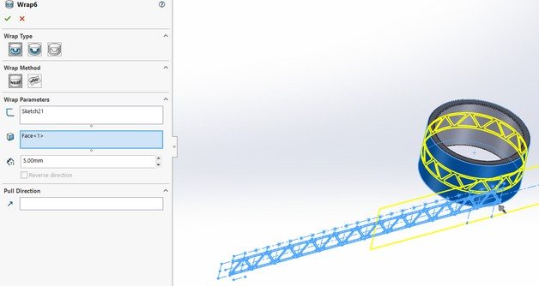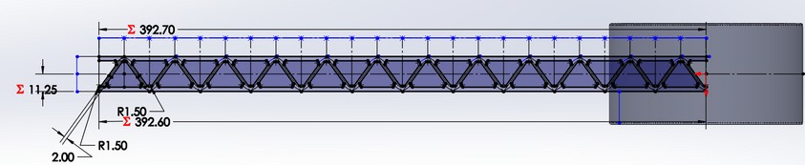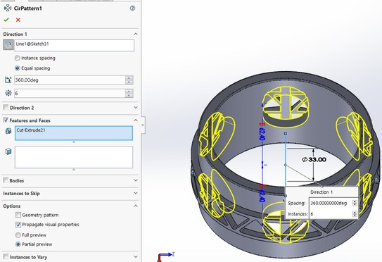

# E L E C T R I C C O I L W I N D E R - D E C E M B E R 1 3 , 2 0 1 9

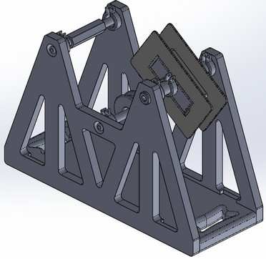Learning from my previous failed attempt at a generator with using the rotor of the alternator, I decided that I needed to make my own coils. I learned that Lundell claw pole rotors' magnetic teeth create the magnetic poles perpendicular to the rotor, and that's why trying to use the rotor for its coils failed.

Wrapping my own coils by hand turned out to be messy and inefficient, and I lost count easily. I decided to make a jig that would make the coil winding process easier. It started toff as a simple bridge like object, with one of its tips holding the bought spool, and the other tip with the coil I wanted to wrap the wire onto. The middle would be used to tension the wire to give me a clean winding.

Inspired by videos on YouTube, I also decided to add a counting device last minute - the calculator. The way it worked was that a magnet on the square spool would close a reed switch when it passed by. This would complete the circuit with the "equals sign" button, meaning that if you pressed "+" "1", then it would add 1 to the sum every time the spool made one full rotation. I debounced the switch with a small capacitor This allowed me to keep track of the windings.

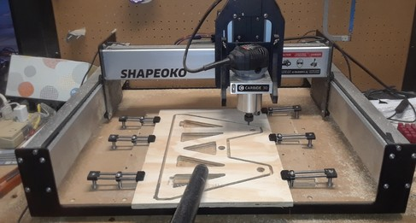The sheer size of the project meant it would have been expensive to print. This is why I opted to CNC it with my robotics team's newly acquired machine.

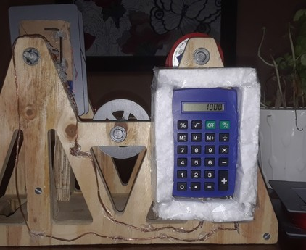

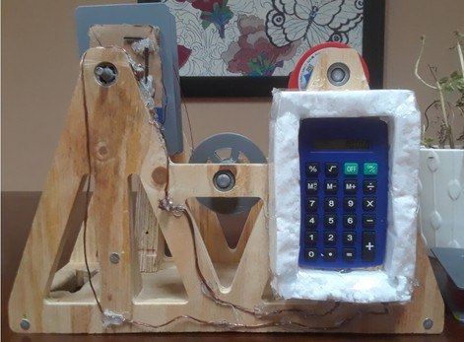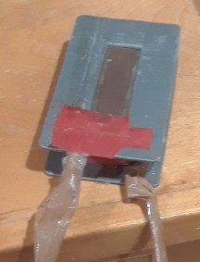

# V A R I O U S P L A S T I C P R O D U C T S - S E P T E M B E R 2 0 2 0 - J U N E 2 0 2 1

**Sterlite Crates - November 2020 & June 2021**

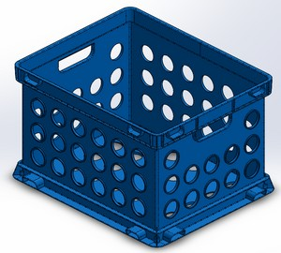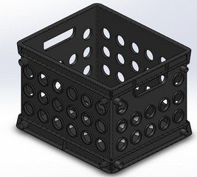

**Sterlite Pencil Case - November 2020**

Being resourceful, I wanted to find a quick housing for a project. I settled on a ready made, fully enclose box, that I could easily open - a pencil case, instead of printing a crate, or building my own (I lack precision, since I have no bench vise, I have to hold everything by hand and feet). It was a mostly simple shape, however, the interesting part was the lip. I had to create a curvy surface in 3 dimensions that was accurate to the lip of the actual crate. This is when I first learned to use surface fill.

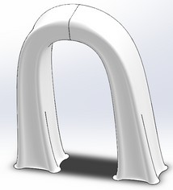**Sleek Handle- September 2020**

Wanting to find a quick, ready built chassis for a gearbox, I settled on a Sterlite crate that you could find at Wal-Mart. I tried sizing and spacing everything properly with calipers and measuring tape to the best of my ability to create the most realistic model. The more realistic they were, the better I could design parts around them. I used linear patterns to get the array of holes for both crates. Later on, in 2021, I would begin to create my transmission out of the mini crate. The parts fit well for the most part, meaning I CADed the crates quite accurately.

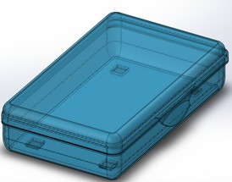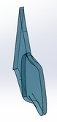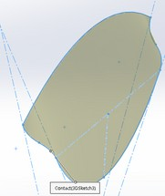

I had just recently started my first semester at CSUF in August 2020, and all classes were online because of the pandemic. Because it ws so early on in the year, the work load was very light, and so out of boredom, I decided to CAD a curvy handle. It was done with simple lofts and mirrors - nothing compared to the surface modeling I would do later. Take note of the shape of the base, and how the "concave" parts smoothly transition to the flat rectangular top.

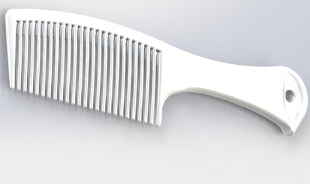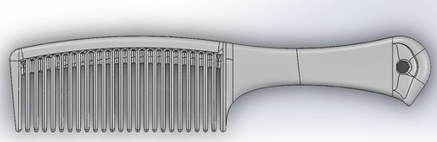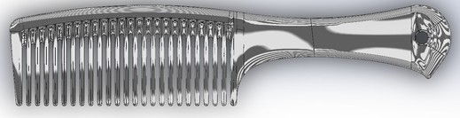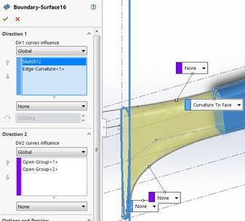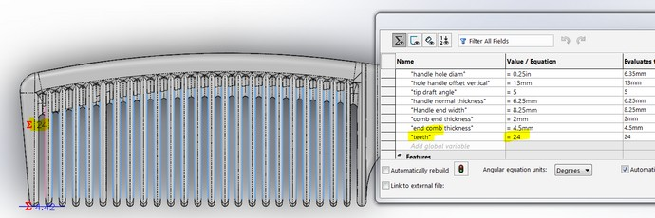

**Plastic Comb - June 2021**

I had just finished my freshman year on a high note, and wanting to celebrate, I CADed a comb that I had. I was excited for this because of all of its curvy surfaces. I made sure that all surfaces smoothly transitioned into each other, and that there were no sharp edges. I did this using boundary and filled surfaces, this time using the "continuous curvature" option, and I checked my work with the zebra stripes. This project was quite difficult because I had no straight edges to work with, aside from the cross section (if you sliced it down the middle), meaning I had to rely on sketches and splitting boundary surfaces. What made it more difficult was that I wanted to vary the number of teeth. I did this by linear patterning a cut extrude for each tooth, and then filleting each.

# W I N D T U R B I N E - A P R I L 9 , 2 0 2 0

This was more of an art project than anything useful. I started CADing it right after school had gone online, because I thought that I needed more practice making curvy shapes. In April 2020, I had only been CADing for about 10 months, and so my only exposure to CADing anything sophisticated and curvy was with lofts, and so this project had no surface modeling. I also did not know about turning tangent edges phantom, so I had to eyeball if surfaces transitioned smoothly into each other. I was wrong in assuming that using smooth guide curves with lofts will ensure a smooth transition. Had I known about using filed and boundary surfaces, I would have used them, since they are more appropriate for a project like this.

Copying from my rocketry fins, I used an asymmetrical airfoil for the base of the blade, and lofted it into a single point in the form of a rounded edge. I also used a Haack shaped nose for the front of the turbine.

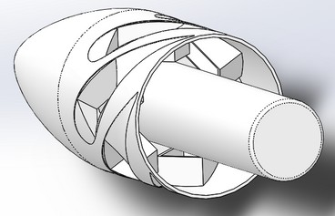This was also the first time I used the flex feature in SolidWorks to smoothly cant the blade 45 degrees over distance.

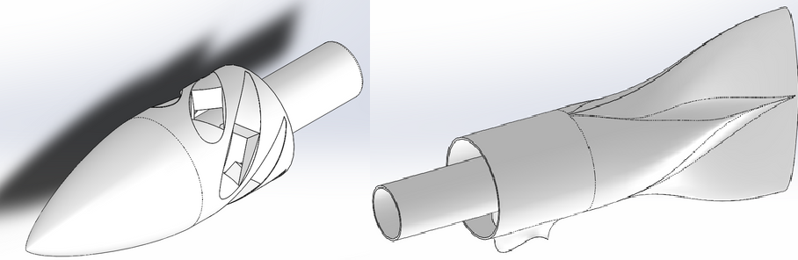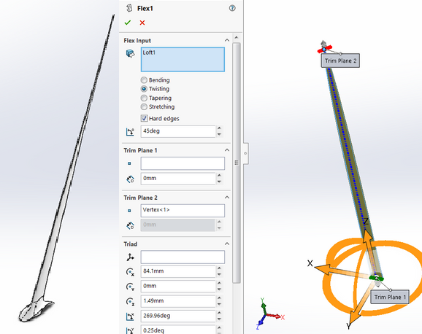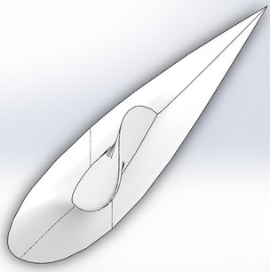

# F A N B L A D E S - M A R C H & A P R I L 2 0 2 1

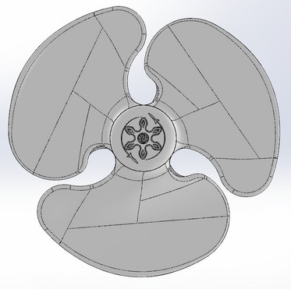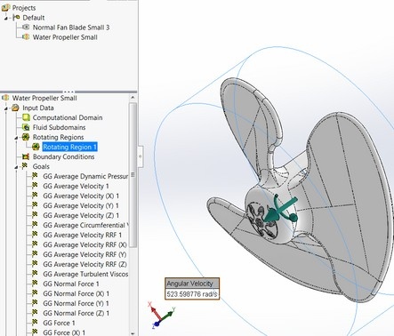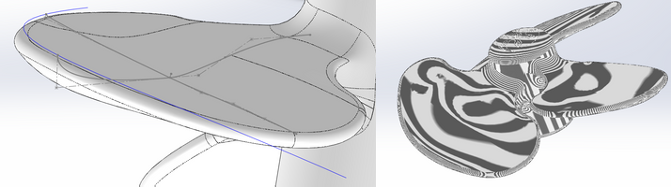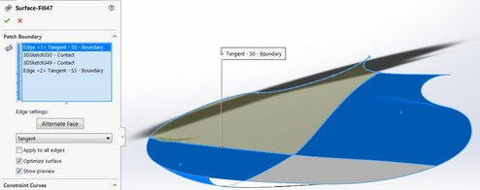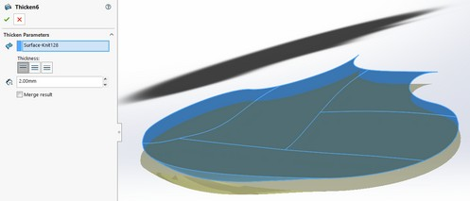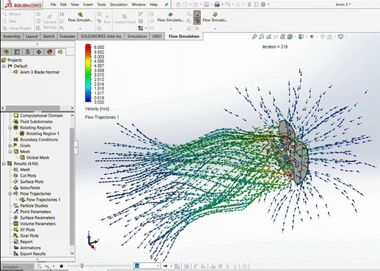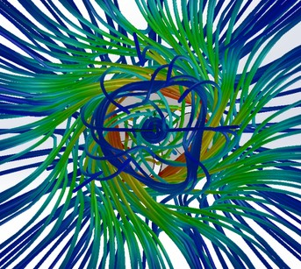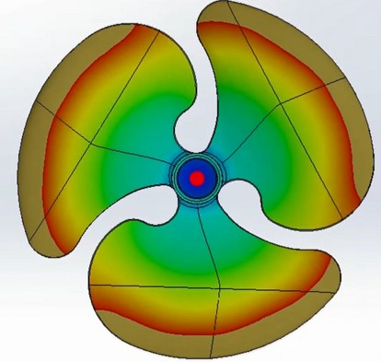

The successor to the wind turbine from a year before, this fan blade is actually smooth all around, and has no sharp edges. This was the first project where I began using boundary surfaces, and where I learned about what the "Contact C0", "Tangent C1", and "Curvature C2" options meant when using surface fill or boundary, and since then, it has helped me immensely. For the first time ever, I used phantom tangent edges and zebra stripes to verify the smoothness, and I was properly able to thicken the fan blade with a variable.

I also properly used rotating regions in this project, simulating the airflow if the fan spun, generating beautiful graphics. I personally find the airflow paths beautiful.

In this project, I also explored the plastic injection molding from SolidWorks Plastics out of curiosity, and I was able to simulate how plastic would flow had I injection molded the fan.

# C L A S H O F C L A N S L E V E L 7 C A N N O N - O C T O B E R 6 , 2 0 1 9

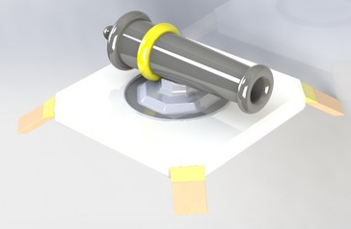By this point, I had SolidWorks for about two months. I had CADed mostly realistic objects, and practical things for my robotics team and for myself. I decided to have a little bit of fun by CADing a cannon from one of the games I played - Clash Of Clans. This project wasn't as steep of a learning curve, as I had already learned to use extrudes, revolves, and lofts. I even learned to use reference geometry prior, allowing me to extrude the legs of the cannon at off angles. However, this was the first project in which I changed materials and appearances, and where I learned to use the Photo360 option to get a nice result.

# M O S I N N A G A N T B U T T S T O C K - M A R C H 9 , 2 0 2 1

I wanted to CAD curvy objects again after designing many blocky projects. I was getting tired of the extrudes and linear patterns, and I wanted to get back into lofting and making some very aesthetically pleasing things.

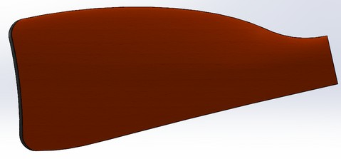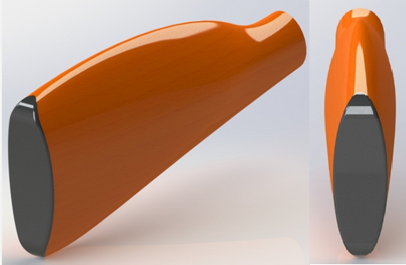

I settled on a Mosin-Nagant buttstock, since compared to other rifles of its time, had the curviest and most complex-shaped buttstock. I thought this would be a nice challenge, and a good way to get back into curvy objects. I wanted to achieve the curves with lofts only- avoiding any fillets. This would prove to be time consuming.

At this point, I had not done any extensive surface modeling, and so I still relied on using lofts. What made this difficult was lofting the butt plate in the rear to the elliptical front, since the butt plate was a 3D sketch. I ended up using four guide curves, and in the end, and even without knowledge of using phantom tangent edges, zebra stripes, and boundary and filled surface C1 and C2 conditions, the project ended up with no sharp edges (except for the abrupt angled "cut" at the front with the ellipse.)

Creating the butt plate proved to be even more difficult. I easily created its shape using surface offsets and thickening it, but the cutaway for the butt plate ended up being the real challenge I ended up shelling the entire object, leaving only the faces that would have made the butt plate. I then ended up using surface offsets and then a surface cut to cut away a space for the butt plate to fit snugly on the end, since cut thicken wouldn't work.

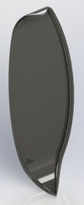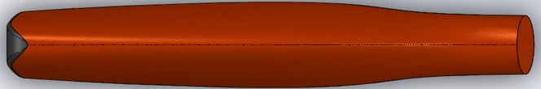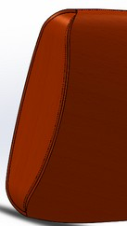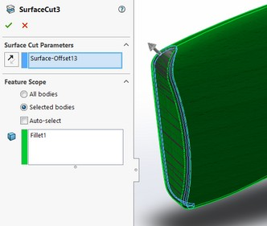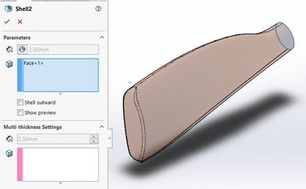

**D O O R L A T C H - J U N E 1 0 , 2 0 2 0**

When my senior year of high school unceremoniously ended during the pandemic, I decided to make my own door latch mechanism out of boredom, and because I recently had to fix my own door. I noticed that my door had plastic torsion springs, which made trying to fix it difficult. Instead, I managed to get the same spring action by using a pen spring inside the latch instead. It worked, and deciding that my idea of using a compression spring was simple than using torsion springs to get the back and forth motion of the latch, I designed my own in SolidWorks.

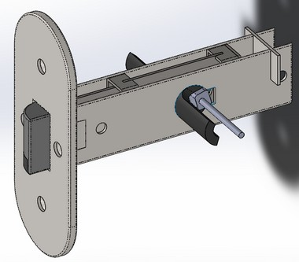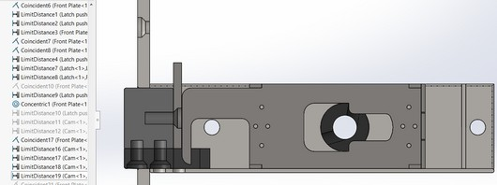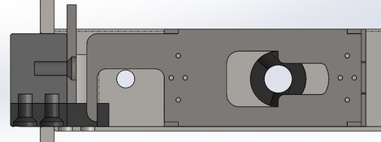

The latch works by having a compression spring in between the back wall and the dark gray piece, forcing it out. When the black piece is cammed (by the knob), it will force the dark gray piece back, compressing the spring, and pulling the latch back. I achieved the camming action with limit distance, as limit angle wasn't working properly in both directions.

The lock works by simply preventing the camming action by jamming it against a slot. The lock is the blue-gray piece.

# V A R I O U S H A R D W A R E C O M P O N E N T S - J U N E - D E C E M B E R 2 0 2 0

In manufacturing, sometimes it is easier, or stronger to use off the shelf parts instead of making and printing your own. This is what I did when I needed hinges, or if I needed to improvise a cheap part for the job.

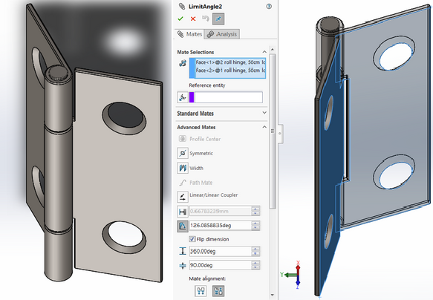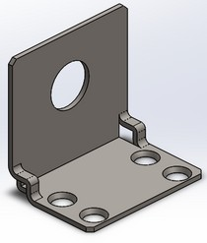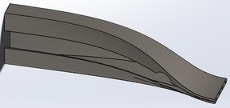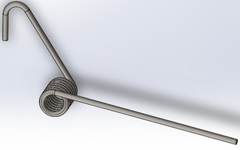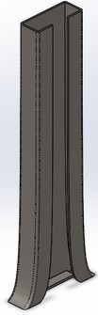

The only problem with CADing these parts is that sometimes, there is no model available online for them. This is especially true for off the shelf components from hardware stores such as home depot. It is important to have an accurate model of any part, even if its cheap and off the shelf, so that it can be planned and CADed around.

This is what I did with things like torsion springs, sheet metal parts, and hinges. I measured each part with a caliper to the best of my ability to get accurate dimensions, and tried placing the holes as accurately as possible by measuring the distance of its edge to the edge of the sheet.

For the sheet metal parts, especially the curvy ones that I bent, I didn't use the sheet metal add in, as I had to worry about minimum curvature radius. I instead just used lofts to achieve those shapes.

In the hinge assembly, I was finally able to get the limit angle mate to work, and the hinge would stop opening or closing if rotated in or out enough.

# 4 B A R C L A W M E C H A N I S M - O C T O B E R , 3 2 0 2 1

In fall 2021, I joined the Titan Rover team at my school, CSUF. On the rover was a mechanical gripper that needed to be redesigned. Although I had not taken a class on 4 bar mechanisms, and did not have a good intuition of them, I decided to try anyway.

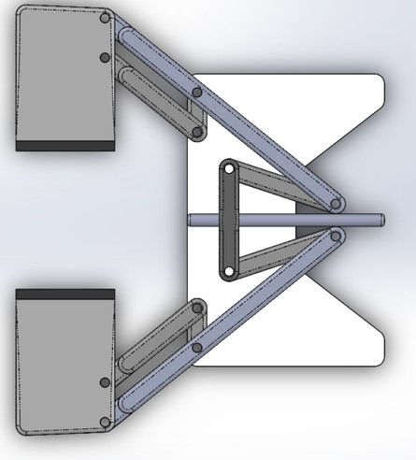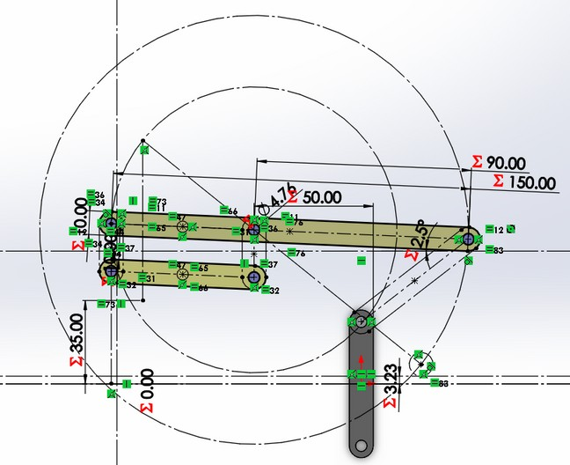

Instead of wanting to guess or randomly input the length of each bar of the mechanism, and then finding out its motion experimentally in the assembly, I decided to CAD all the parts at once, saving each as a configuration.

In the sketch, I had defined the length of each arm by its shape in resting form, and other parameters, such as its minimum width when the gripper is closed all the way. I also ensured that the bars would not hit the actuator rod when fully closed, using a variable to input a clearance. I also allowed the location of the joints to change, giving different mechanical advantages.

In the end, I built a parallel 4 bar gripper mechanism in 5 hours. Sadly, they decided not to change anything by the time I finished, because they were on a time crunch, and could not afford the time to redesign anything.

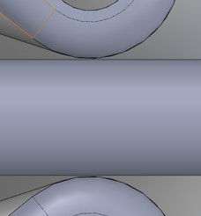

# G E A R S H I F T T R A N S M I S S I O N - J U N E 2 0 2 1 - A U G U S T 2 0 2 2

From June 22 to August 12, I worked on a gearshift.

